ENCODERS

An [**encoder**](http://www.anaheimautomation.com/products/encoder/encoder-products.php) is a sensor of mechanical motion that generates digital signals in response to motion. As an electro-mechanical device, an encoder is able to provide motion control system users with information concerning position, velocity and direction.

There are generally two types of encoders:

1.LINEAR ENCODER

2.ROTATORY ENCODER

**BLOCK DIAGRAM OF ENCODER**

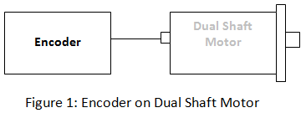

**Basic Types of Encoders**

Linear and rotary encoders are broken down into two main types:

1.ABSOLUTE ENCODER

2.INCREMENTAL ENCODER

The construction of these two types of encoders is quite similar; however they differ in physical properties and movement. This type of encoder utilizes sensors that use [**optical**](http://www.anaheimautomation.com/products/encoder/optical-incremental-rotary.php?tID=1054&pt=t&cID=422), mechanical or [**magnetic**](http://www.anaheimautomation.com/products/encoder/optical-incremental-rotary.php?tID=1063&pt=t&cID=422) index counting for angular measurement.

**Incremental Encoders**   
  
[**Incremental rotary encoders**](http://www.anaheimautomation.com/products/encoder/rotary-encoders-list.php?cID=422) utilize a transparent disk which contains opaque sections that are equally spaced to determine movement. A light emitting diode is used to pass through the glass disk and is detected by a photo detector. This causes the encoder to generate a train of equally spaced pulses as it rotates. The output of incremental rotary encoders is measured in pulses per revolution which is used to keep track of position or determine speed.

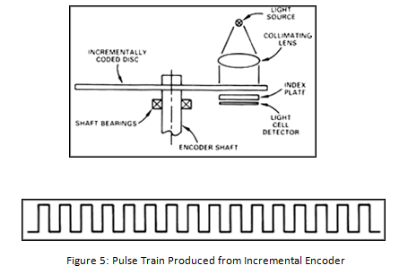

A setback of the incremental encoder is count loss which occurs during power loss.

**Absolute Encoder**

An absolute encoder contains components also found in incremental encoders. They implement a photodetector and LED light source but instead of a disk with evenly spaced lines on a disc, an absolute encoder uses a disk with concentric circle patterns.

**WORKING**  
Absolute encoders utilize stationary space in between the photodetector and the encoder disk as shown below. The output signal generated from an absolute encoder is in digital bits which correspond to a unique position. The bit configuration is produced by the light which is received by the photodetector when the disk rotates. The light configuration received is translated into gray code. As a result, each position has its own unique bit configuration.

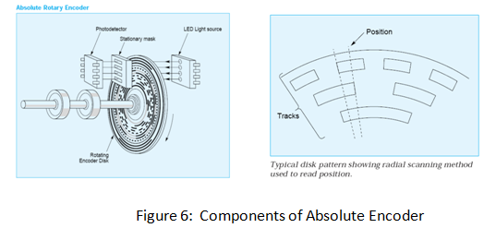

Now,Coming to encoders which was mentioned:

**1.LINEAR ENCODERS**

A linear encoder is a sensor, transducer or reading-head linked to a scale that encodes position. The sensor reads the scale and converts position into an analog or digital signal that is transformed into a digital readout. Movement is determined from changes in position with time. Both optical and magnetic linear encoder types function using this type of method. However, it is their physical properties which make them different.

It can be subdivided into two types:

**1.Magnetic Linear Encoder**

A Linear MAGNETIC Encoder system uses a magnetic sensor readhead and a magnetic scale to produce TTL or analog output for Channel A and B. As the magnetic sensor passes along the magnetic scale, the sensor detects the change in magnetic field and outputs a signal. This output signal frequency is proportional to the measuring speed and the displacement of the sensor. Since a linear encoder detects change in the magnetic field, the interference of light, oil, dust, and debris have no effect on this type of system; therefore they offer high reliability in harsh environments.

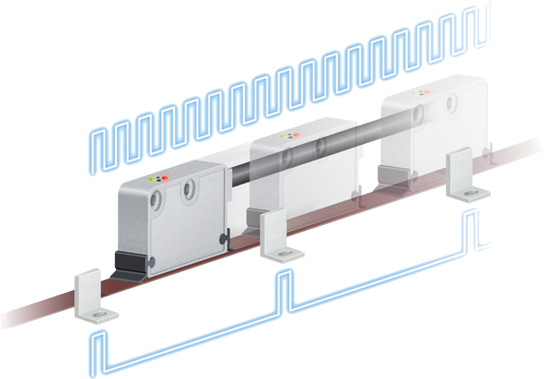

IMAGE SHOWING LINEAR MAGNETIC ENCODER

**2.OPTICAL LINEAR ENCODERS**

The light source and lens produce a parallel beam of light which pass through four windows of the scanning reticle. The four scanning windows are shifted 90 degrees apart. The light then passes through the glass scale and is detected by photosensors. The scale then transforms the detected light beam when the scanning unit moves. The detection of the light by the photosensor produces sinusoidal wave outputs. The linear encoder system then combines the shifted signals to create two sinusoidal outputs which are symmetrical but 90 degrees out of phase from each other. A reference signal is created when a fifth pattern on the scanning reticle becomes aligned with an identical pattern on the scale.

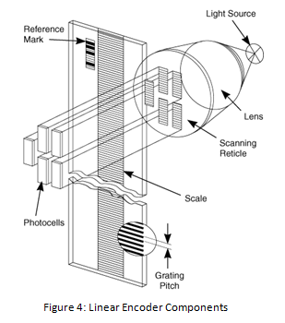

**2.ROTATORY ENCODER**

**[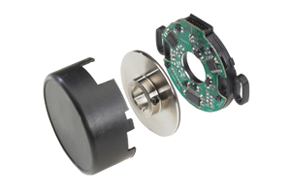](http://www.anaheimautomation.com/products/encoder/optical-incremental-rotary.php?tID=1063&pt=t&cID=422)**IMAGE SHOWING ROTATORY ENCODER

A magnetic encoder consists of two parts: a rotor and a sensor. The rotor turns with the shaft and contains alternating evenly spaced north and south poles around its circumference. The sensor detects these small shifts in the position of NORTH AND SOUTH POLES. There many methods of detecting magnetic field changes, but the two primary types used in encoders are: Hall Effect and Magneto resistive. Hall Effect sensors work by detecting a change in voltage by magnetic deflection of electrons. Magneto resistive sensors detect a change in resistance caused by a magnetic field.

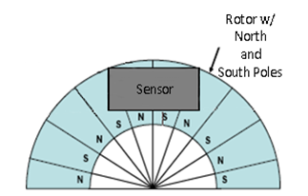

**Hall-Effect sensing**  
The Sensor produces and processes Hall-Effect signals producing a quadrature signal as is common with optical encoders. The output is generated by measuring magnetic flux distributions across the surface of the chip. The chip face should be parallel to the magnet so the magnet to sensor air gap is consistent across the sensor face.

**ENCODER COMMONLY USED NOWADAYS**

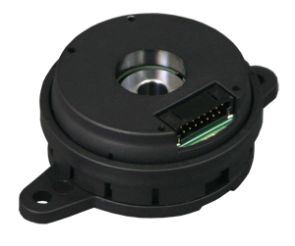

**Commutation Encoders**

A commutation encoder contains the same fundamental components as incremental encoders but with the addition of commutation tracks alongside the outer edge of the disk for U/V/W output.

**WORKING**

[**Commutation encoders**](http://www.anaheimautomation.com/manuals/forms/encoder-guide.php) utilize a transparent disk which includes opaque sections that are equally spaced to determine movement. A light emitting diode is used to pass through the glass disk and is detected by a photo detector. This causes the encoder to generate a train of equally spaced pulses as it rotates. The output of incremental rotary encoders is measured in pulses per revolution which is used to keep track of position or determine speed.   
  
The outer part of the encoder disk includes commutation tracks which provide a controller with information on the exact position of the motor poles, so that the proper controller input can be supplied to the motor. The commutation tracks of the encoder read the motor position and instruct the controller as to how to provide efficient and proper current to the motor to cause rotation.

**APPLICATIONS OF ENCODERS**

An encoder can be used in applications requiring feedback of position, velocity, distance, etc. The examples listed below illustrate the vast capabilities and implementations of an encoder:

• Robotics  
• Labeling Machines  
• Medical Equipment  
• Textiles  
• Drilling Machines  
• Motor Feedback

• Assembly Machines  
• Packaging  
• X and Y Indication Systems  
• Printers  
• Testing Machines  
• CNC Machines